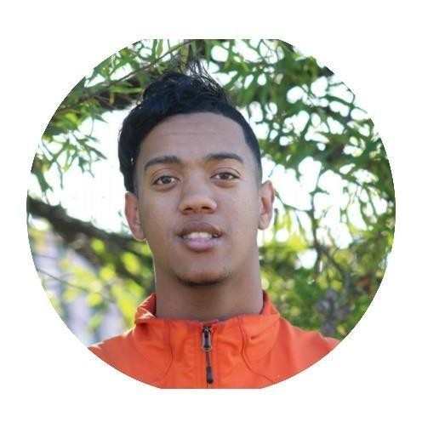

**Carlton Anthony Visagie**



**Junior Full Stack Developer**



+27 (0)61 622 7696

[carltonvisagie@gmail.com](mailto:carltonvisagie@gmail.com)



Retreat, Cape Town, 7945



|  |  |
| --- | --- |
| **PROFILE** | I am a creative, committed and business minded individual. I’m a conscientiousness and dedicated individual who is open to new experiences and to learning new things. I’m an aspiring Junior Full Stack Developer and seeking to advance my digital skills so I can be an excellent Full Stack Developer. My core values are hard work, achieving my goals, being of service, communication, discipline and building relationships in the workplace. |
| **EDUCATION** | **Full Stack/Web Development Certificate**  Hyperion Dev, Co-Grammar | 2019   * Web Development Essentials * Programming with Python, Javascript and Jquery * Restful API’s * React.js and Express.js modules   **Go from zero to hero in Python 3 Certificate**  Udemy | 2018  **Matric (NQF 4)**  Grassy Park High School | 2017 |

|  |  |
| --- | --- |
| **SKILLS** | HTML **|** CSS **|** JavaScript **|** JQuery **|** React.Js **|** Node.Js **|** Express.Js **|** Python **|** Bootstrap **|** GitHub **|** GitLab **|** Heroku **|** Vue.Js**|** Mongo.DB **|** Firebase **|** PHP**|**  Quick-thinker **|** Problem-solver **|** Goal driven |



# WORK EXPERIENCE Intern Developer (Internship)

Webworx Web Design | May 2021– October 2021

## Assisting on Wordpress Sites

* + Creating Custom Shortcodes to display specific data on a page
  + Page Building : adding new content for clients
  + Working with various themes editors such as Gutenberg and Total with custom styling.
  + Creating Projects using React, Bootstrap, Javascript, Jquery and handlebars.

# Intern Developer (Internship)

L.C Studio | September 2020 – May 2021

## Backend Developer | Frontend Developer

* + Setting up an Express App with all secure (installing) dependencies
  + Monitoring login & registration of a user
  + Developing of websites and making it functional with the backend
  + Working with a Database that handles the data that comes into and go’s out of the website

# WordPress Developer

March 2021 - Current

## Freelancer | Designer| Hosting & Domain Registration

* Managing of websites, Blogs and Reviews
* Controlling the social media platform, such as Facebook and Instagram
* Maintaining and updating

# I.T Specialist

ConnectZA | April – July 2020

## Networking | Installations | Software & Hardware

* Installling of Network cables (Rj45)
* Routers and Antenna setup
* Troubling shooting problems, fixing and updating Software
* Installing Software

# Product Specialist

Atomic Marketing | October 2019 – January 2020

## CUSTOMER SERVICE | SALES

* Having product knowledge (Bosch Power Tools)
* Building a rapport with customers
* Ensuring promotion stand is tidy and occupied at all times

# Warehouse Packager (Casual)

Murray & Roberts | January 2019 – February 2019

## PACKAGING | INVENTORY

* + Packaging items correctly to ensure safe transport and no damage.
  + Heavy lifting of items from warehouse to transport vehicle
  + Doing stock take ensuring there were enough specified/required items



 



**REFERENCES**



Available On Request

## My Github profile

<https://github.com/carlton2000/>

## My Heroku profile

<https://dashboard.heroku.com/account>/

## Digital portfolio



<https://carlton-portfolio.netlify.app/>

## My LinkedIn profile



<https://www.linkedin.com/in/carlton-visagie-a59257193/>